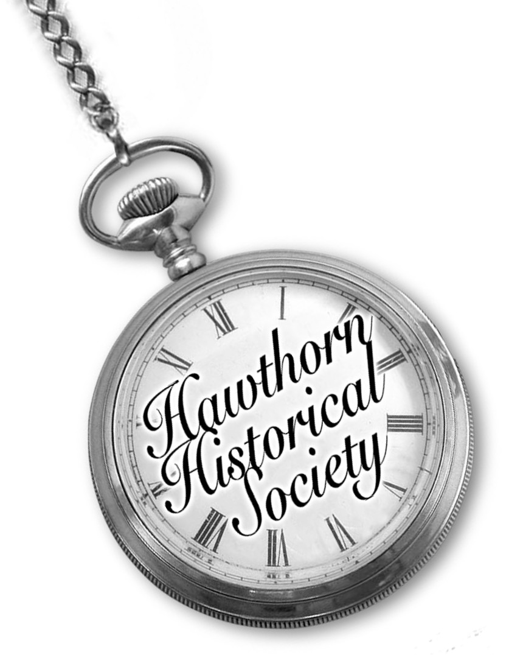

Hawthorn

Historical Society

Newsletter 🞄 November 2016

*AGM 2016   
L – R Elizabeth Love, Ian Smith, Guest Speaker from CATHS. Elizabeth Yewers and John Pesutto, Member for Hawthorn*

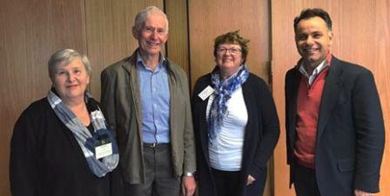

Contents

*Committee News Page 3*

*What’s been Happening? Page 3 - 4*

*Article: Henry Walsh by Bill Mackie (Part 2) Page 5 - 9*

*Hawthorn in Cape Town by Albert Isaacs Page 9- 10*

*Coming Attractions Page 11*

*Annual Report Page 12 - 14*

P

Hawthorn Historical Society is affiliated with the Royal Historical Society of Victoria

Postal Address: Box 8, Hawthorn Community Precinct,

584 Glenferrie Rd, Hawthorn. 3122

Phone: Please contact one of our committee members – see below

Email: [hawthornhistoricalsociety@gmail.com](mailto:hawthornhistoricalsociety@gmail.com)

Hawthorn Historical Society

|  |  |  |
| --- | --- | --- |
| **PATRON** | John Pesutto MP  Member for Hawthorn |  |
| **PRESIDENT** | Ms Elizabeth Love | 0408 176 905 [e.a.love@bigpond.net.au](mailto:e.a.love@bigpond.net.au) |
| **VICE PRESIDENT** | Ms Elizabeth Yewers | 9819 1218  [lizyewers@hotmail.com](mailto:lizyewers@hotmail.com) |
| **SECRETARY/ MINUTES** | Ms Andrae Talarico | 0411 980 523 |
| **TREASURER / PUBLIC OFFICER** | Ms Pamela Carter | 0400 644 042 |
| **COMMITTEE MEMBERS** | Ramona De Niese |  |
|  | Jenny Bowen |  |

We can now send out your newsletter by email!

[hawthornhistoricalsociety@gmail.com](mailto:hawthornhistoricalsociety@gmail.com)

If you would like to receive future newsletters this way.



|  |
| --- |
| **Hawthorn Historical Society Publications** |

***Faint traces: Chinese in Hawthorn   
before the Second World War***Diane Nicholas & Mary Sheehan, $15

***Hawthorn streets index***Gwen McWilliam, (reprinted 2004) $22

***Street Walks***   
Village Walk (revised 2015) - $7.50

Other Walks by Gwen McWilliam, $7 *per set*

***A Glimpse of Glenferry***Articles by Ruth Dwyer $20

**Hawthorn History Walks**

Discover the history of Hawthorn with a series of self-guided walks produced by the Hawthorn Historical Society.

Sets for the walks are available from

Hawthorn Library for $5.00 each.

**Committee News**

Dear Members and Friends

We are

Dear members and friends.

I would like to introduce myself as the incoming President of the Hawthorn Historical Society. I've been a member and active on the committee since 2012 so will be familiar to some of you. For those who don't know me I welcome the opportunity to talk to you about the Society on the phone (0408 176 905) or at one of our future meetings.

I am very gratified that after some difficult years the Society is moving forward in a very positive way. This is in no small way, thanks to the strong leadership and dedication of our past presidents and in particular I want to sincerely thank Liz Yewers for her tireless work over the past two years.

2016 has proved to be an exciting and innovative year with new initiatives and increased participation. At the Annual General Meeting in October Oriel Flewell-Smith, Andrae Talarico, Ramona De Niese and Elizabeth Yewers were re-elected to the committee and were joined by Jenny Bowen as a new member.

We are looking forward to another productive year and want to wish you all a safe and happy Christmas and New Year.

Libby Love  
President

**What’s been Happening?**

It was good to see so many people at our Re-Living Hawthorn Memories day in August. This comprised an exhibition of still photographs produced from the 1907 film “Living Hawthorn” and some short talks by members and guests. We were encouraged to see our members, once again, sharing the fruits of their research. Thanks to **Oriel Flewell-Smith** and **Elizabeth Love.**

**Barney Meyer’s** presentation was a real eye opener. He demonstrated the ways in which interactive digital displays are being used to bring history and historical places alive. Barney has been involved in some interesting projects with the National Trust of Victoria. His Virtually There Exhibition takes visitors on a journey through interactive virtual reality exhibits including Rippon Lea mansion and a visit to the McCrae Homestead. This continues at Geelong until the end of February 2017. Details available from National Trust Victoria.

There was a good turnout for a tour of the Boroondara Cemetery in September with expert guide **Tony Michael** relating the history of the Cemetery as well as notable ‘residents’.

In October we were pleased to be involved in the launch of **Jennifer O’Donnell’**s latest publication about the house Kawarau, the home of the Cato family in Tooronga Road. This is a fine production with many photographs and plans. You can purchase a copy direct from Jenny. Details elsewhere in this newsletter.

And at our AGM in October, **Ian Smith** from the Cinema and Theatre History Society of Australia took us for a journey down memory lane recalling ‘going to the flicks’ on a Saturday night. This was a splendid talk where we learnt about the ‘flash’ front of the early cinemas which promised more than they delivered in terms of comfort. We also gained insight into the power brokers of this new industry and how they wrestled for control of our suburbs.

In this edition of our newsletter we have the second part of Bill Mackie’s story of Hawthorn pioneer **Henry Sallows Walsh**  and the Walsh family. You will recall that this was prompted by our acquisition of some memorabilia belonging to Michael O’Grady which had been made by Walsh Bros. jewellers. Elizabeth Love presented the story of O’Grady at the Re-Living Hawthorn Memories day. Subsequently, she and Jim Love produced a short video of her talk. You can see this at <https://vimeo.com/182175830>

Also, we have an intriguing article by Albert Isaacs about a suburb in Cape Town South Africa which sounds as though it has been confused with Hawthorn: Riversdale Road, Glenferrie Road and many more.

Look out for our coming events. We hope to see you there.   
Elizabeth Yewers

Editor

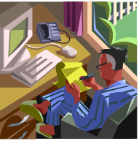

WEBSITE NEWS

Have you seen our updated website yet? Take time to take a look. We’ll gradually be adding material over time. And do be patient while we come to grips with the new systems. The address hasn’t changed.

Go to <http://www.hawthornhistoricalsociety.com.au/>

While you are there you’ll find a link to our latest Facebook postings. You don’t need to subscribe to Facebook to see these interesting stories. And we are not far away from having 600 followers. That’s something to celebrate.

KAWARAU

By

Jennifer O’Donnell

Kawarau, in Tooronga Road, built in 1893, was most famously the home of Frederick Cato until his death in 1935. It later saw service as Stephanie’s Restaurant and is now Alia College.

Jennifer O’Donnell has produced this book which looks in detail at the construction and life of this interesting building. It is meticulously researched with detailed footnotes and is lavishly illustrated with contemporary and historic photographs, maps, brochures and historic news items.

**Copies of KAWARAU $25 + postage   
from the author:  
jennnn3040@telstra.com**

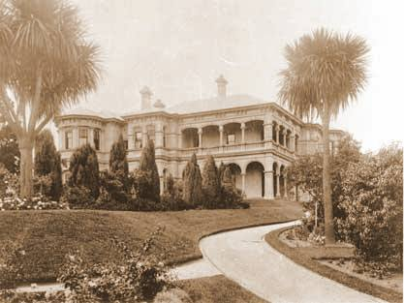

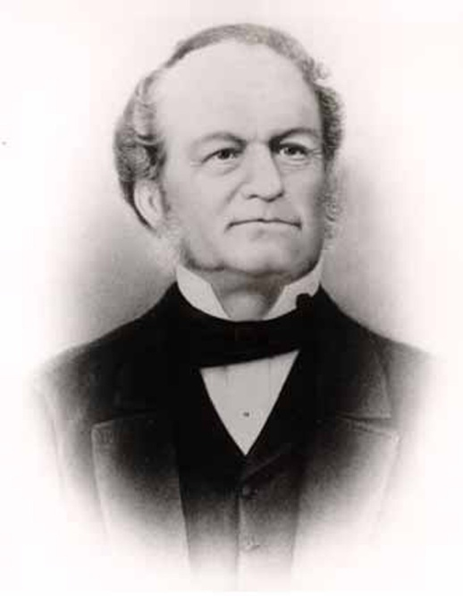**Henry Walsh – A Notable Pioneer of Hawthorn – PART 2**

Henry Walsh

**By Bill Mackie, great-great-grandson of Henry Walsh**

**Henry Walsh, pictured, came to live in Hawthorn   
in 1853, when he purchased 18 acres (7.2 ha) of land**

**where Lisson Grove is now situated. He was a**

**man of great enterprise and energy, doing**

**much for the communities of Boroondara and**

**Melbourne. This article continues the story of   
Walsh Bros. jewellers, Henry Walsh and the Walsh family.**

**Walsh Bros. - Jewellery, tableware and presentations**

The discovery of gold in Victoria in 1851 brought many people and much wealth to Melbourne. Walsh Bros. was regarded as the largest jewellery business in colonial Victoria. The firm was a leading supplier of high-class clocks, watches and jewellery. It commissioned Victoria’s best goldsmiths and silversmiths to make trophies, testimonials, epergnes, and other table-ware. Eminent craftsmen in Victoria who were involved in commissions by Walsh Bros. included William Edwards, Edward Fischer, and Julius Hogarth.

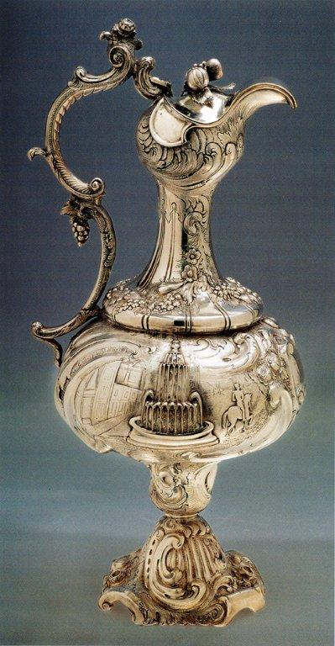Two substantial items associated with the Walsh family business have historical interest. One is a large silver claret jug that was designed and made by William Edwards of Melbourne. Its history starts in August 1859, when the first ornamental street fountain in Melbourne was erected at the intersection of Collins and Swanston Streets to celebrate the city’s newly piped water supply from Yan Yean Reservoir**.** It was named the Victoria Fountain and was officially opened by the Mayoress, Mrs Phoebe Walsh. In recognition of this duty she was presented with a large claret jug by the Corporation of the City of Melbourne. Phoebe subsequently gave the jug to Henry’s grandson, Henry Bowring Walsh (son of Frederick), for his 21st birthday. The fountain became known as the Dolphin Fountain because its basin had six dolphins supporting the central column, but its initial position at the centre of the street intersection obstructed the traffic so within 3 years it was moved to the Carlton Gardens, where it survived for a number of years before being removed.

**Silver claret jug, 42 cm high, made by William Edwards for the Melbourne City Council.**

Source: Geelong Gallery

The other item, also made by Edwards, for Walsh Bros. under a commission from the Melbourne City Council in 1864, was a bridal present for Princess Alexandra, who in 1863 married Edward, Prince of Wales. A large epergne, its design was to embrace:

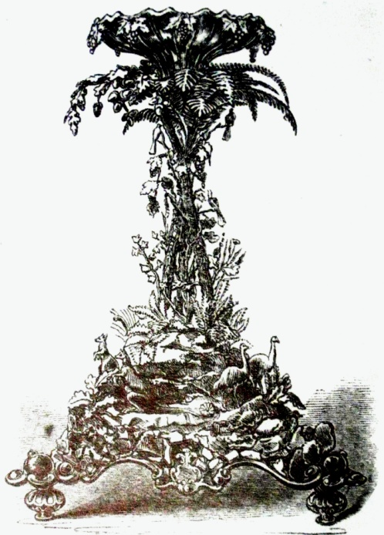

*‘A base of rock work, upon which animals native to Australia are placed and above which two stems, one of vine and the other of fern, rise, meeting at the top, and supporting a bowl of burnished silver. The stem will be of gold. The birds, rock work and foliage with the animals below are to be frosted silver, the stand of blackwood with silver mountings and shields for arms and inscriptions. The work will contain 40 ounces of 18 carat gold and 200 ounces of St. Arnaud silver, and cost 300 pounds.’*

This bridal present was purchased with funds from shilling subscriptions given by “the colonists of Victoria”. It was put on display in October 1864 at Walsh Bros. premises. The design was changed slightly, with an oak tree and a fern tree, each of gold, being bound gracefully together by a vine species and to convey an allegory with the fern, representing Victoria, tied by the vine that is common to the old and new world.

**Epergne, made by William Edwards; a bridal present from the ‘colonists of Victoria’ for Alexandra, Princess of Wales.**

The Illustrated London News, April, 1865

***Longfield***

Henry Walsh was about 47 years old when he settled in Boroondara. At some time in about 1853 he bought from the original owner Thomas Payne Lot 47, it being one of about eighty Crown allotments in Hawthorn offered for sale in 1851-53; many allotments were sold for three to four pounds per acre. Walsh’s block was 7.2 hectares (18 acres) of farmland six kilometres (3½ miles) east of Melbourne city, on elevated ground close to the Yarra River. It extended from Power Street to Glenferrie Road. He named his little farm *Longfield*. This was his home for about twenty years. Lisson Grove, running from Power Street to Glenferrie Road, now occupies much of the original Walsh property. In 1856 Henry Walsh had a weatherboard house near today’s corner of Lisson Grove and Power Street. Henry and Phoebe in 1873 moved to a new brick house, still standing today, at 22 Shakespeare Grove, Hawthorn.

At *Longfield* Henry established an orchard and a five acre vineyard. He was an active member of the Horticultural Society of Victoria, which established Experimental Gardens where the Burnley Gardens and the Horticultural College campus of Melbourne University are now located. A report of the July 1863 meeting of the society records that Mr H.S. Walsh of Hawthorn donated a China flat peach and a seedling apple, which he had raised and named ‘Longfield seedling’. At a horticultural show in February 1862, Walsh won first prize in the class for ‘native wine’, being for his Longfield white wine of 1858 vintage and second prize for his wine of 1860. In 1867 Walsh’s Longfield wines were served at a reception for the Duke of Edinburgh (Prince Alfred) who was visiting Melbourne. Walsh was president of the Melbourne Vine Growers Association in 1867.

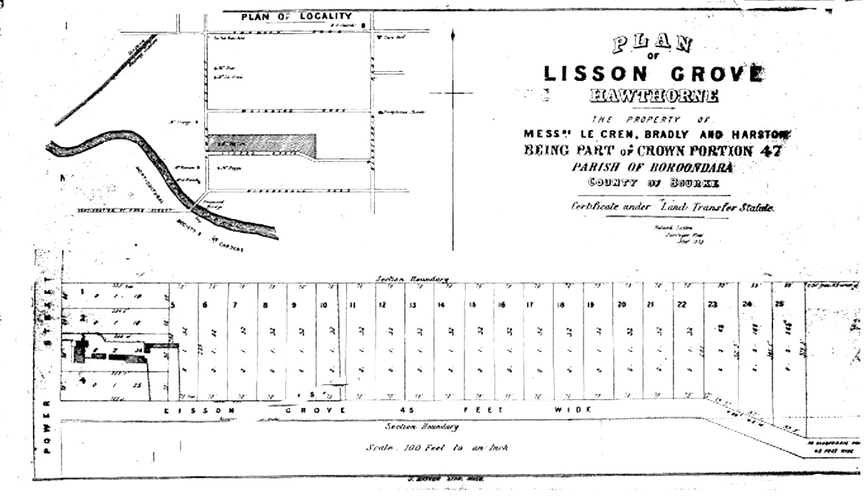

**Subdivison plan for Lisson Grove in November 1873 shows location of the  *Longfield* homestead beside Power Street,**

**Henry Walsh’s Public activities**

Soon after his arrival in Melbourne Henry Walsh became involved in public duties. In 1852 he was elected to represent the Hotham Ward of the Melbourne City Council. He was also a Justice of the Peace, an appointment entailing magisterial duties.

The Church of England established its first church east of the Yarra River in Boroondara. Built in 1853-1854, Christ Church still stands on the corner of Church and Denham Streets, Hawthorn. Governor La Trobe gave a beautiful baptismal font to the church in 1854. In 1855 Henry Walsh donated a large wall clock, inscribed ‘Walsh & Co. London’[1]. He was reported to have presented a clock to St Joseph’s Catholic Church, Hawthorn, at about the same time.

In 1856-57 Walsh was elected as the first chairman of the Boroondara District Road Board, a municipality which was established to raise revenue to maintain roads in the district. When Hawthorn and Kew became municipalities in 1860 he presided over the first election of Hawthorn councillors. The remnant area of the Boroondara Road District became the Shire of Boroondara, later the Shire of Camberwell, and in 1914 the City of Camberwell. In 1994 Camberwell, Hawthorn and Kew were merged into the City of Boroondara, which virtually embraces the original Boroondara Road Board District. A photograph of Henry Walsh used to have pride of place with the photographs of the mayors of the City of Camberwell in the Camberwell Town Hall.

In the 1850s Henry was the first chairman of the City of Melbourne Gas and Coke Company, which supplied gas in 1856 for street lighting in Melbourne. He was also first chairman of the Melbourne and Suburban Railway Company, which was formed in 1857. It built lines first from Princes Bridge to Richmond, then in 1860 to Windsor and in 1861 to Hawthorn.

A document from the archives of the Melbourne City Council describes how Henry Walsh became Mayor of Melbourne. In 1858, at the end of one of John Smith’s many terms in office, city finances were low and Council morale depressed. Determined to rid themselves of Smith, all councillors except Walsh voted against Smith at the mayoral election, and Walsh became mayor with the task of bringing order to the city’s affairs.

In September 1869 Walsh became a member of the Legislative Council in the Victorian Parliament. He resigned in May 1871 due to ill-health. He died on 6th July 1877 at his home in Shakespeare Grove and was buried in the Melbourne General Cemetery (Compartment R, Grave 461).

Apart from some street names no monument, or less tangible memorial, in Melbourne seems to commemorate Henry’s achievements in his trade, businesses and service to the community. His portrait, painted as Mayor of Melbourne, was destroyed by fire in the Melbourne Town Hall in 1925.

**Henry Walsh’s Family**

The eldest of Henry’s three sons was Henry Thomas Harrington Walsh who lived in Warrnambool from 1854 until he died in 1888, having traded as a watchmaker and jeweller. In 1859 he married Marianne Kirby in Melbourne; aged 28 she died in Warrnambool in 1869. Because of his distance from Melbourne he seems to have had limited contact with the family in Melbourne and declined to be an executor, with his brothers, of his father’s will. When he supplied a large clock for the Warrnambool Post Office it carried the name of Gaunt & Co.!

Second son Frederick helped run the family business throughout his time in Melbourne. In 1854 he married Elizabeth Dwyer, a devout Catholic who, with a Mrs Norton, subscribed for the installation of a major stained glass window in the Church of the Immaculate Conception in Hawthorn; regrettably her name is not beside that of Mrs Norton below the window. They lived in Hawthorn with their family of 7 sons and 6 daughters, of whom eight survived infancy. A former residence of Frederick’s still stands in Victoria Road in East Hawthorn. Frederick served on the Hawthorn Borough Council and was Mayor in 1867- 68. He was a Member of the Legislative Council in 1868-74 and 1881- 83, and was a member of the Royal Commission on Noxious Trades in 1870. He died in 1903 in Hawthorn.

In 1885 Frederick helped his two elder sons Henry Bowring (Harry) and Frederick Richard (Fred) purchase the pastoral leases comprising *Mileura* *Station*, a 250,000 ha (620,000 acre) sheep and cattle property situated in the Murchison district of Western Australia.  Some years later a younger son, Francis Edward (Frank) also moved to WA. The descendants of Frederick Richard Walsh and Francis Edward Walsh form the nucleus of the WA branch of the Walsh family which is descended from Henry Walsh of Boroondara.

Alfred William Walsh was Henry’s youngest son and shared management of Walsh Bros. with his brother Frederick until the business was sold in 1881. Alfred married Maria Margaret Woods in 1866; born in Launceston in 1848, she was the daughter of a notable sea captain in the Bass Strait trade. On retirement Alfred became a ‘real estate and stock broker’ but lost most of his capital during Victoria’s severe financial recession of the early 1890s. He died in 1917 in Rochester, Victoria. A granddaughter of Alfred said that his wife Maria persistently urged her husband to change his occupation from one of trade to one of higher social status. Perhaps she considered all trades were noxious! Their eldest daughter Mary married Copland Mackie, a tea merchant from Edinburgh, and was the grandmother of Bill Mackie, author of this biography. Alfred’s other offspring resided in Melbourne, except for son Alfred William (Paddy) who spent most of his life in Hawaii and California, Eric who had a small irrigation farm west of Rochester, in northern Victoria , and Doris (Dor) who married Edmund (Ted) Body of *Bundemar*, Trangie, NSW.

**Principal Sources and Acknowledgements**

* Thomson, Kathleen & Serle, Geoffrey (1972) *A biographical register of the Victorian legislature,1859-1900.* Australian National University Press, Canberra.
* Arnold, V. H.(1973) *Victorian Year Book.*
* Loomes, B. (1989) *Watchmakers and Clockmakers of the World*, vol. 2, 2nd Edn., N.A.G. Press, Colchester, Essex.
* Bruton, E. (1989) *The History of Clocks and Watches*. Crescent Books, New York.
* Britten, F. J. (1899) *Old Clocks and Watches and their Makers,* 9th Edn. 1986, Methuen, London.
* Port Phillip Directory for 1851.
* Melbourne City Council Corporate Information Services.
* Museum Victoria, Melbourne.
* Sands & Kenny, Melbourne Directory 1855. 1857 & 1858
* Sands & McDougal, Melbourne Directory 1862.
* Powerhouse Museum, www.powerhousemuseum.com/collection/database/?irn=186781.
* FamilySearch™ International Genealogical Index v5.0.
* FamilySearch™ Ancestral Files v4.19.
* McWilliam, G. (1978) *Hawthorn Peppercorns*. Brian Atkins, Hawthorn.
* Paynting, H.H. & Grant, M. (1985) *Victoria Illustrated 1834-1984.* James Flood Charity Trust*,* Melbourne.

**Special thanks to**

* The late Mrs Ruth Dwyer, Hawthorn, for much historical material extracted from early Victorian newspapers and public records relating to Henry Walsh.
* Mrs Mary Walsh, Mosman Park, WA, for historical information on Henry Walsh and
* Frederick Walsh’s family members in Western Australia.
* Mr A.G. McDonald, Librarian, British Horological Institute, Upton Newark, Notts., England.

**HAWTHORN IN CAPE TOWN Albert Isaacs**

Hawthorn in Cape Town!!

My great-uncle Ernest Hart, my maternal grandmother’s brother, fought with the combined Australian colonial forces in the Second Boer War. He fell in love with a South African girl, he married her and they settled in Cape Town. Thus, I still have relatives living in Cape Town, although, later, parts of that branch of the family moved to Britain and to Israel.

Some time ago, probably in the 1970s, I was having a conversation with my brother and made a throwaway remark to the effect that Uncle Ernest was probably not the only Australian Boer War soldier to stay in South Africa and that there may be a story or two to be told. Much later, in 1995, my brother visited South Africa and sent me a photocopy of a page from *Cape Town and Peninsula Street Map*, the local street directory, showing the streets in the southern Cape Town suburb of Crawford. (The page was sent just before many of us had access to Google Maps.)

A search of Google Maps for the suburb of Crawford in Cape Town will be of interest to all those who know the Melbourne suburbs of Hawthorn and Richmond. You will see, inter alia, streets in Crawford include Glenferrie Road, Riversdale Road, Taronga Road (sic – the same spelling as Sydney’s Taronga Park Zoo), Burwood Road, Camberwell Road, Clive Road, Burnley Road and Church Street. Interestingly, Glenferrie Road and Burwood Road intersect! There are also a few *ring-in* roads including St Kilda Road, Melbourne Road and Perth Road.

Although it doesn’t appear on the map, presumably because it’s a minor thoroughfare, Bridge Way is just north of Camberwell Road but running from St Kilda Road to Burwood Road only.

Crawford railway station is on the very scenic, electrified, suburban Cape Flats line which terminates at Retreat. Crawford is the tenth of the 16 stations between Cape Town and Retreat.

In Hawthorn, Clive Road is a comparatively insignificant residential street, but in Crawford it appears to be a major road running alongside the railway line. This leads me to suspect that whoever set up this estate may have earlier lived in Clive Road, Hawthorn. Unfortunately, despite extensive online research, I haven’t been able to discover the name of any Boer War soldier who had resided in Clive Road, Hawthorn. Should anyone be able to give me any further help on this matter, it would be much appreciated!

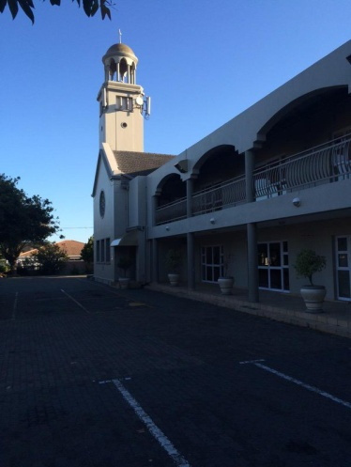The large mosque and Muslim centre, Masjid Hall, (left) is on Taronga Road and is very much a local landmark.

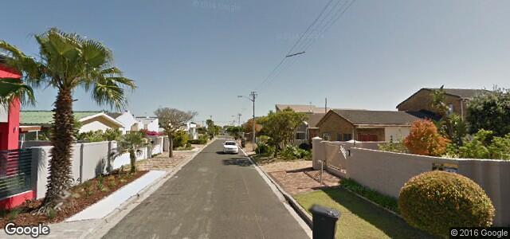The homes in this area appear to date from the Art Deco era of the late 1920s or early 1930s. If the person who set up this estate had originally come to South Africa during the Second Boer War (1899-1902) then, theoretically at least, he or she *(hypothetically we may even be referring to a nurse)* may just have accumulated enough money by the 1920s or 30s to have built such an estate. Below is a typical streetscape of the area, having been taken in Taronga Road, and with Masjid Hall in the background.

The homes suggest the area is quite affluent and in the Apartheid era it would, likely have been a Whites Only region and the high walls around many of the houses support this. A friend who recently visited Cape Town tells me that the contemporary residents in the district are mainly affluent Black South Africans.

So! Who knows what other stories there are that relate to Australians who later moved to South Africa?

*Note: Albert provided us with other images and maps which we couldn’t include here. If you would like to see them, Please contact us.*

ACKNOWLEDGEMENTS

Victor Isaacs

James Thomas

MapStudio, *Cape Town and Peninsula Street Map*

Google Maps

Google Images

Sanha Halal website

Tixus real estate website

East London Property for Sale website

Wikipedia

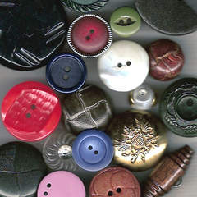

Coming Attractions

**FLOWERS & GARDENS IN EMBROIDERY   
AND NEEDLEWORK**

. A feast for the eyes   
**Lindy Bajurnow** and **Nadia Malaspina** bring their creative experience and historical knowledge to provide us with a wonderful display. A short presentation will reveal the back-story of their creations and the history of buttons.   
See and hear of the imaginative uses of needlework   
in repurposing the old.

All Welcome

Information: 0408 176 905

hawthornhistoricalsociety@gmail.com

Sunday 13th November

2.00 pm

Hawthorn Community Precinct

584 Glenferrie Road

Hawthorn 3122

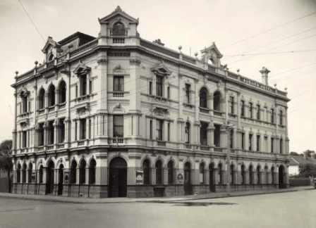

**CHRISTMAS DRINKS**

Sunday 4th December

4 pm to 6 pm

Join us for a celebration of all the achievements of 2016 in this historic Hawthorn hotel built in 1888.

Catch up with old friends and make some new ones.

All Welcome

Information: 0408 176 905

hawthornhistoricalsociety@gmail.com

Auburn Hotel

85 Auburn Road,  
Hawthorn East 3123

Sunday 4th December

4 pm – 6 pm

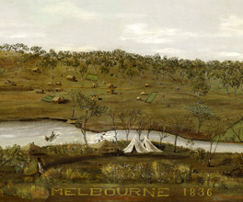

**EARLY MELBOURNE**

**1835 – 1851**

Historian **Loreen Chambers** will share   
her knowledge about the early days   
of Melbourne   
from first camp to Separation

Hawthorn Community Precinct

584 Glenferrie Road

Hawthorn 3122

Saturday 18th February 2017

All Welcome

Information: 9819 1218

hawthornhistoricalsociety@gmail.com

**OTHER DATES**

**Local History Room** **Hawthorn Library 11am to 1pm Every 2nd & 4th Wednesday**

Wednesday 9th November Wednesday 23rd November (final for 2016) Sessions resume Feb 2017

**6th March 2017 – GLENFERRIE ROAD FESTIVAL**

**Late March – Yarra Street History Walk**

**22nd April 2017 - Ian HUNDLEY – “The Rise & Decline of the Suburban Landscape in Boroondara”**

**HAWTHORN HISTORICAL SOCIETY Inc.**ABN 85 074 207 584

**ANNUAL REPORT**

**1 OCTOBER 2015 – 30 SEPTEMBER 2016**

We have continued to maintain the momentum of last year with opportunities for our members to hear some fine speakers and to be involved in interesting research, collection of archives and other projects. We’ve continued to engage with our local community through the schools, the traders, our events and our sessions in the Local History Room at the Hawthorn Library and we continue to receive research queries from members of the public on a very regular basis.

Boroondara Council has sought our advice in designing way-finding signs which acknowledge the history of various precincts and we were invited to run guided tours of the former Hawthorn Town Hall for the Melbourne Open House weekend. An audit of the 1985 Bicentenary Historic Plaques was undertaken and **Oriel Flewell-Smith** has been invited to join the committee to review Council’s Plaque Policy. Zoning and planning issues have continued to be high on the agenda and we have worked with a number of residents in their planning applications.

And there were surprises along the way. Early in 2016 the committee was approached by an individual who offered for sale two items referring to Michael O’Grady M.L.A.. These were a silver plated ewer and presentation goblet given to him in 1862. In view of the fact that O’Grady was a key player in early Boroondara and early colonial Melbourne we approached the Mayor and Councillor Hurd as well as the Hawthorn Arts Centre Curator and Library Staff to discuss how we should approach the curatorship of such items. It was their opinion that memorabilia was not part of the acquisition policy of Council or any of its cultural bodies. We proceeded with the purchase, nevertheless, and are continuing to seek a permanent home for these items.

It gives great satisfaction to see a research enquiry come full circle. In April, Elizabeth and Robert Yewers were privileged to join the descendants of Sapper Arthur Cooper, at the Australian War Memorial in Canberra as Cooper’s Bible was returned to the family. This Bible has spent nearly 100 years in Ireland, having been lost in WW1 at Gallipoli. It was a pleasure to have been part of the research team identifying this soldier and his family.

It is also exciting to meet the historians of the future at Auburn Primary School. Elizabeth Love and Elizabeth Yewers had the pleasure of spending a morning with the Grade 3 & 4 students to help them with their local history projects. We realised that nine year olds have a different perspective on what constitutes ‘history’, and that even 1980 is several life times away for them.

Although we do not currently have an active member of the Boroondara Library Service on our committee, Letitzia Mondello, Hawthorn Library team leader, has been supportive of our work. Thanks go to Adria Ferugia for her assistance with the photographs for the Reliving Hawthorn Memories event and to Janey Ginger for printing the newsletter.

We were sad to farewell two long-standing members and stalwarts of our Society during this year. **Betty Marginson** died soon after our AGM, in December 2015 at the age of 92. **Margot Dorum** died in July this year, still actively working on a history project related to her new home at St Joseph’s Mews. Margot and her husband were founding members of the Society in 1974. Both sadly missed.

Through our ongoing research projects we have amassed a considerable resource relating to Hawthorn’s history and looking forward, our goal is to secure a ‘home’ to centralize our records and our collections as well as a place to conduct  research and to display items.

**MEETINGS & EVENTS:**

It was lovely to see so many attend our AGM in 2015. It was a time to celebrate many things including the appointment of our patron **John Pesutto** **MP**. We are pleased to have him on our team. In addition, we were delighted to award a Life Membership of the Society to past President **Shirley Ramsay** whose leadership over many years was marked by her graciousness and ability to encourage others in their work. We were also pleased to welcome **Dr Elizabeth Rushen** as our guest speaker talking about her research into female migration in the 1830’s. And woven into the story of these early settlers was that of James Pinnock, immigration agent and Hawthorn pioneer.

We started 2016 with a **Picnic in Morang Reserve** anda visit to the Wurrundjeri Gardens in February. Thanks to **Ellie Bastow** for coming and giving us a background to the work which has been taking place there.

The **Glenferrie Road Festival** on 6th March was again a great success. People were interested in the early photographs and there were “I’m a History Detective” badges and a quiz for the children. **Lindy Bajurnow** produced two beautiful canvases of an Edwardian lady and gentleman with the faces cut out and **Jim Love** obliged by taking people’s photographs posing in them. The Street Festival is a lovely opportunity to meet the locals and raise our profile.

We were lucky that the weather held in April for our street/riverside walk in the vicinity of **Creswick Street**. This took in the history of Palmer’s punt, the Chinese market gardens, the floods along the Yarra and the lives and homes of the ordinary folk as well as various notables including James Pinnock and Henry Creswick of ‘The Hawthorns’ in Creswick Street, the Burstons of Carrical and the Mansons of Huntingtower.

**Albert Isaacs’** talk in April on “The Jews of the Eastern Suburbs” was wide ranging and outlined the development of various synagogues in the area into the present age. He also spoke about important members of Melbourne Jewry, particularly those with a Hawthorn connection.

A visit to Ripponlea to see the costumes from the film of The Dressmaker had us all enthralled by the collection of mid-century hats. They were so very stylish. The costumes, too spoke of some elegant fashion from the 1950’s.

In June, we joined with **Richmond and Burnley Historical Society** for a very successful event at the Hawthorn Rowing Club overlooking **The Hawthorn Bridge** which was the topic of our talk. **Ken McInnes** outlined the development of this bridge in its various stages with many interesting illustrations. His engineering background allowed him to give the non-engineers in the audience a clear understanding of the structural beauty and importance of this metal truss bridge. Ken has made a particular study of the accomplishments of the bridge’s designer, colonial civil engineer, **Francis Bell** (1821 – 1879) whose work was far reaching but not widely recognised. Some 50 people heard this very fine talk. Thanks go to the Hawthorn Rowing Club for so generously hosting us.

And on a cold Saturday morning in July we received a warm welcome at the **Melbourne Tram Museum.** It was great fun climbing into the old trams and reliving memories. Thanks to the volunteers at the Museum for sharing their knowledge and congratulations to them on the celebration of the Centenary of the Hawthorn Tramways Trust.

We thought our Show & Tell in 2015 would be hard to beat but were delighted to present **Re-Living Hawthorn Memories 2016** in August. The display focused on a re-showing of still photographs made for the Society in 1980, drawn from the 1907 film “Living Hawthorn” which was re-shown on the day. This display was augmented by matched photos taken in 1980 and more recently, in 2016, by Jim Love. Our speakers included **Oriel Flewell-Smith**, talking about the Darling Family and **Elizabeth Love** talking about Michael O’Grady. **Barney Meyer** opened our eyes to the new ways in which history can be presented through interactive digital displays which allow us to enter inaccessible places and times.

There was a good turnout for a tour of the Boroondara Cemetery in September with expert guide **Tony Michael** relating the history of the Cemetery as well as notable ‘residents’.

The year was capped off by the launch of member **Jennifer O’Donnell’**s new publication about the house Kawarau, the home of the Cato family in Tooronga Road. Jennifer is an accomplished researcher and photographer and an inspiration to us.

**PROJECTS & PUBLICATIONS**

Thank you to **Elizabeth Love** for her hard work in putting together the collection of articles written by the late Ruth Dwyer, “A Glimpse of Glenferry”. This has been a huge project with many hours of editing but there are some fine articles to be found in this publication and it well worth reading.

This acquisition of the Michael O’Grady memorabilia lead Elizabeth Love to research his life and to present it as part of the **Re-Living Hawthorn Memories** event in August. This has been followed by the development of a short film of this material by Elizabeth and her husband Jim Love. This innovation enables us to present local history information at a new level and to a new audience.

Congratulations to **Jenny Bowen** who is driving a project to audit the homes in the St James Park Precinct. This involves photographing each house in the area, thanks to Elizabeth Love, and collecting current information about these houses.

We have continued to collect, scan, or photograph material related to Hawthorn and add newspaper articles relevant to Hawthorn under our Trove account at National Library of Australia and to keep a current real-estate file. These are on-going and large projects with plenty of opportunities for members to become involved.

**TECHNOLOGY**

This year the HHS has put considerable effort into making the best use of social media technology, largely through the efforts of Elizabeth Love. This has taken a number of forms such as; regular email contact with our members, responding to research queries through our g-mail account, growing the number of interested followers on Facebook and providing further historical material on our website. We now have over 560 followers on Facebook - our posts regularly reach up to 1000 people. Whilst it does not necessarily translate to a rise in membership it has significantly increased the community’s knowledge of Hawthorn history, it’s awareness of our organisation and events, and also has prompted many people to share invaluable information, photos and memorabilia with us.

Our first website was created by Swinburne University students more than five years ago and was based on an early version of Joomla management system. We had found this program cumbersome and inefficient. The cost of the required upgrade was considerable and advice suggested that there could be a better use of money. This year we contracted Paul Churton from Webdynamix to create a new and more efficient website for us using Word Press. We are very pleased with the new streamlined website and believe it is now easier to share responsibility for managing information and uploading resources.

**COMMITTEE**

We thank retiring committee member Lindy Bajurnow for her contribution to our committee. Thanks go to Pam Carter who has capably taken over the job of Treasurer and to Andrae Talarico, Ramona De Niese and Oriel Flewell-Smith for their contributions to the smooth running of the organization over the year and for their involvement at the Wednesday Local History sessions.

Much of the drive for the work we have undertaken this year has come from the energy of Elizabeth Love who has a creative vision of where our Society can go and a desire to help us go there. We are pleased that she has agreed to stand as President for 2017.

But the Society cannot rely only on a few individuals. We need involvement of all our members and we need to encourage others to join us. Don’t be deterred if you feel you haven’t the skills to undertake a task. We have all learned on the job. There are many small ways you can assist in preserving the history of Hawthorn for future generations and it’s amazing what you can learn along the way. And have some fun while you are doing it.

**Elizabeth Yewers**Retiring President

1. *See HHS August 2016 Newsletter for an image of this clock*